CHINESE WUSHU & TAICHI ACADEMY LLC

709 ½ S. King Street, Seattle WA 98104, (206)749-9513

[www.chinesewushutaichi.com](http://www.chinesewushutaichi.com)

Yang TaiChi Group Class for Beginners on Oct.4, 2011

**Location**: 709 ½ S. King Street, Seattle WA 98104

**When**: Tuesday 6:00P.M. – 7:00P.M. Starts October 4, 2011 on going

**Fees**: $200/10 weeks includes tuition, uniform and registration fee. ***Limit 15 students***

**Instructor**: Sifu Yijiao Hong

**What to expect in this class**: Authentic and detailed Yang Taichi movements of simplified forms and Chinese traditional medicine Qigong warm-ups will be taught step by step following physical learning science. Sifu Hong will also explain how Taichi originated from ancient Chinese philosophy and Chinese medicine. As a beginning student the skill of self-centering, body relaxation and slow breathing while learning and practicing those movements are emphasized. You expect to become more flexible, stronger legs, coordinated, balanced and relaxed in an energetic way.

**What to expect in this class**: Sifu Hong will give in-depth instruction on authentic Yang Taichi form movements and Qigong warm-ups from Traditional Chinese Medicine, using the latest in physical learning science. Sifu Hong will also explain how Taichi originated from ancient Chinese philosophy and Chinese medicine. As this class is for beginning students, the skills of self-centering, body relaxation, and slow breathing while practicing form movements are emphasized. You can expect increased flexibility, leg strength, coordination, and balance, as well as learning to be relaxed in an energetic way.

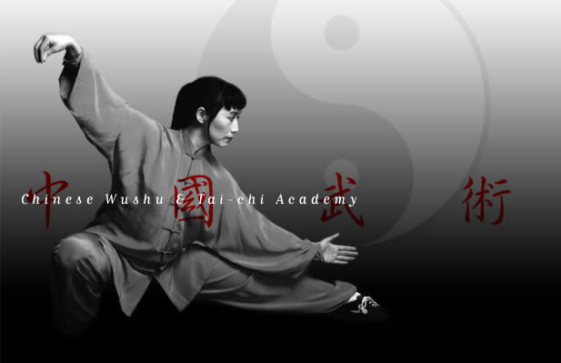

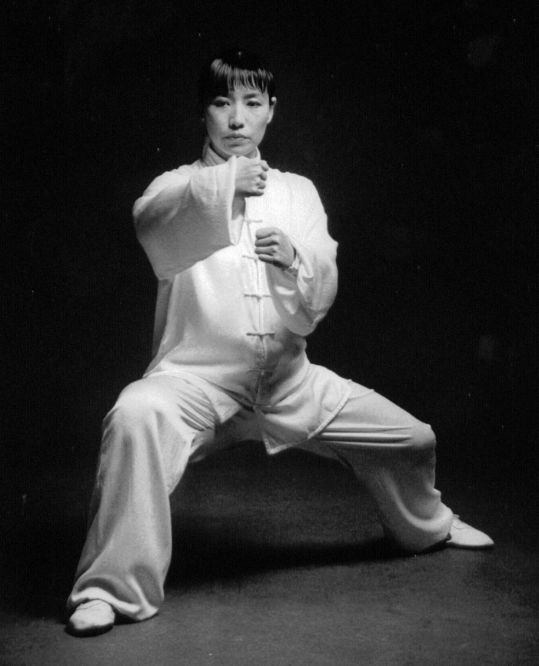by Master